Tab 1

The Impact of Chronic Academic Stress on Overall Quality of Life
A survey-based exploration into how academic stress affects student well-being


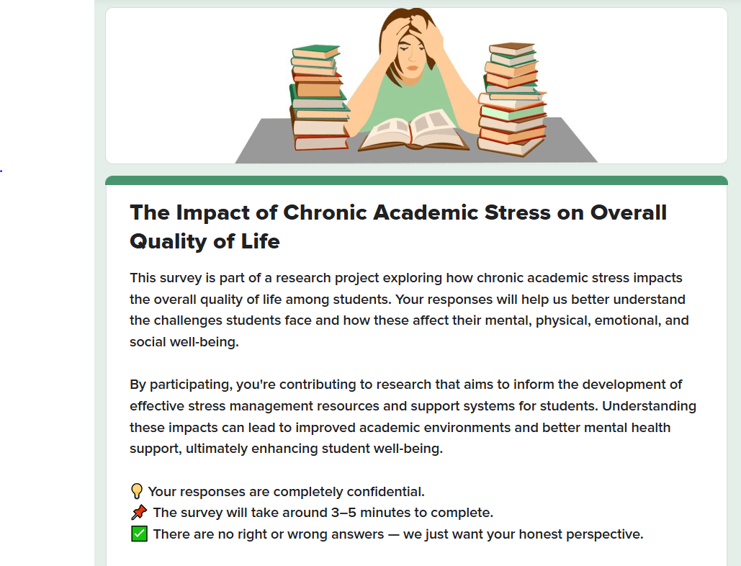

Project Team  Nabira Khan  Arwa Abbas  Hamna Khalid  Amna Rais  Mehwish Zehra  Nimrata Baby  Shaheer Malik | 23K-0914  23K-0721  23K-0700  23K-0824  23K-0773  23K-2070  23K-0897 | Submitted to  Ms. Aqsa Fayyaz  Lecturer, Psychology  Date of Submission  April 30, 2025

INTRODUCTION
Chronic academic stress refers to the prolonged exposure to academic demands, such as exams, assignments, and deadlines, which can lead to negative effects on students' mental and physical well-being. With increasing academic pressures, students often face difficulties in balancing their studies with their personal lives. This study aims to explore the relationship between chronic academic stress and the overall quality of life, focusing on the various factors that contribute to this stress and its impact on students.
The topic was chosen because academic stress is a significant concern for students, affecting their academic performance, emotional health, and social lives. Chronic academic stress has been shown to lead to burnout, anxiety, depression, and physical ailments. As students ourselves, we wanted to voice our beliefs about the challenges posed by academic stress and back them up with evidence. We aim to highlight these effects and contribute to discussions on improving student well-being by understanding the stressors that negatively affect their lives.
This research aims to explore the relationship between chronic academic stress and the overall quality of life of students. Specifically, the study seeks to identify the major sources of academic stress; how it affects students’ mental and physical health, social interactions, and overall life satisfaction. Additionally, the study aims to examine whether gender differences exist in the experience of stress, and to evaluate the effectiveness of different coping strategies employed by students. This research is designed to offer valuable insights into how academic stress influences students and how support mechanisms can be improved.

METHODOLOGY
Research Design
- Survey Type: Cross-sectional online survey
- Purpose: To assess the impact of chronic academic stress on students' overall quality of life
- Platform: Google Forms was used to create and distribute the survey
- Structure: 6 sections covering demographic data, stress levels, impact on quality of life, and coping strategies
Participants
- Sample Size: A total of 101 students participated in the survey.
- Demographics: The sample included students from various academic years (e.g., first-year to final-year) and disciplines (e.g., engineering, social sciences, medical sciences).
- Inclusion Criteria: Participants were selected from a broad academic pool to ensure the survey results reflected a wide range of student experiences.
- Exclusion Criteria: Students who were not currently enrolled in academic courses or who had not experienced academic stress were excluded from the study.
Data Collection Tools
1. Introduction & Consent: Participants were informed about the purpose of the research, confidentiality, anonymity, and the time required (3-5 minutes). Consent was obtained from all participants, ensuring voluntary participation.
2. Demographics: Questions regarding age, gender, level of education, and field of study to understand participant background.
3. Academic Stressors: Identification of primary sources of stress (e.g., exams, assignment deadlines), frequency of stress, and balance between study time and other activities.
4. Impact on Quality of Life: Questions examining the effect of academic stress on sleep patterns, social life, happiness, self-esteem, physical health, and relationships.
5. Coping Strategies: Inquiry into coping mechanisms (e.g., exercise, socializing), effectiveness of these strategies, and use of institutional support services such as counseling.

Survey Design and Structure
Likert Scale: A five-point Likert scale (1 = strongly disagree to 5 = strongly agree) was used to assess the intensity of stress experienced by students in relation to various factors (e.g., workload, exams, deadlines).
Multiple Choice Questions: Questions about coping mechanisms (e.g., “Which of the following methods do you use to cope with stress? a) Exercise, b) Meditation, c) Time management, d) Talking to friends”).
Procedure
Development of Survey: The survey was developed and validated with the help of academic advisors and peers to ensure clarity and relevance.
Pilot Testing: The survey was pilot-tested with a small group of students to identify any issues in wording or question structure. Adjustments were made based on feedback.
Distribution of Survey: The final survey was distributed online using Google Forms. The survey link was shared via email and social media platforms to ensure broad accessibility and reach.
Data Collection Period: The survey was open for responses for 1 week, during which reminders were sent out to increase participation.
Ethical Considerations:
- Informed Consent: All participants were informed about the nature of the study and gave their consent to participate voluntarily.
- Anonymity: Responses were anonymous to ensure that personal details did not influence the findings.
- Confidentiality: No identifiable information was collected, and the data was stored securely.
Quantitative Analysis:
- Descriptive statistics (mean, standard deviation) were used to summarize the stress levels and impact on well-being across different groups (e.g., gender, year of study).
- Frequency analysis was conducted to identify the most common stressors and coping methods.
- Cross-tabulation analysis was used to identify any gender-based differences in stress levels and coping strategies.
Independent Variable and Dependent Variable
Independent Variable: Chronic academic stress, measured through the frequency and intensity of academic-related stressors such as exams, deadlines, workload, and personal responsibilities.
Dependent Variable: Overall quality of life, which includes physical health, emotional well-being, social life, self-esteem, and academic performance, all of which were assessed concerning academic stress.

RESULTS
Key Findings from Survey Responses
1) Demographic Information
- Age: Majority (70%) aged 16-20, 30% aged 21-25.
- Gender: Approximately 60% male, 40% female.
- Education Level: 90% undergraduate, 6% high school, 5% other.
- Field of Study: Computer Science/AI/Cyber Security, etc, dominates (70%), with other fields including Business, Medicine, and Engineering.
2) Academic Stress Levels and Frequency
Based on Likert Scale (4-5):
- Perceived manageability of academic responsibilities: 40% reported that academic responsibilities feel "often" or "very often" unmanageable.
- Time spent studying vs. leisure: 28% spend significantly more time studying than on leisure activities.
- Frequency of anxiety about deadlines/exams: 53% experience frequent anxiety about deadlines/exams.
- Impact on sleep patterns: 56% report that academic stress affects their sleep patterns often.
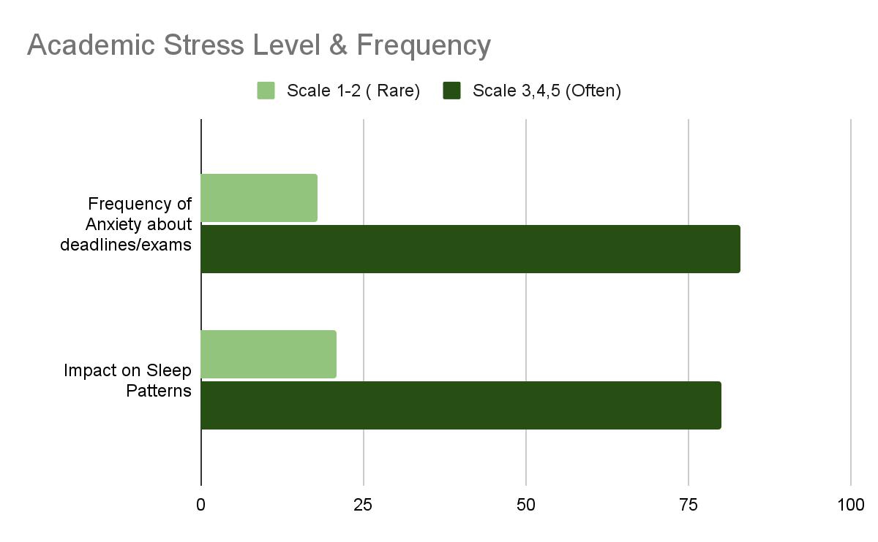

3) Effects of Academic Stress (Impact on quality of life)
Based on Likert Scale (4-5):
- Effects on happiness and self-esteem: Approximately 62% say stress impacts their overall happiness and self-esteem.
Based on Answers “Yes” or “Sometimes”:
- Impact on personal relationships: 77% report stress negatively affects personal relationships "sometimes" or "often"
- Social withdrawal: 87% have withdrawn from social/recreational activities due to stress.
- Physical health consequences: Academic stress has led to 79% changes in students’ physical health (headaches, weight changes, fatigue, etc).
- Academic performance decline: 83% noticed academic performance decline due to burnout.
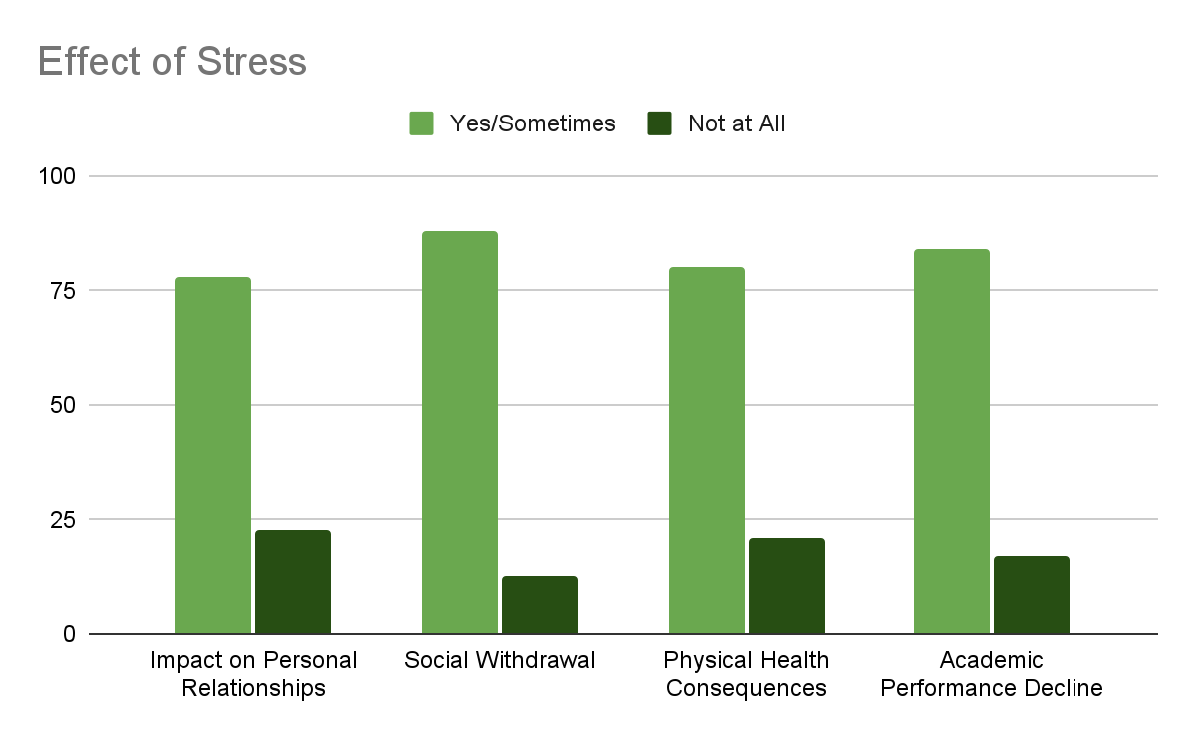
4) Top Stress Sources
- Major Academic Stressors
Top 5 Stress Sources:
  - Exams and test preparation (66.3%)
  - Heavy course workload (55.4%)
  - Time management challenges (49.5%)
  - Assignment deadlines (44.6%)
  - Unclear academic expectations (25.7%)
- Comparison of stress sources across demographics: Computer Science students report higher stress from heavy workloads (75%) compared to students from other fields.
- Unrealistic expectations: 69% feel academic expectations placed on them are unrealistic.
5) Academic Burnout Symptoms
Based on Likert Scale (4-5):
- Mood swings: 51% experience frequent mood swings during deadlines.
- Loss of enjoyment: 52% find it hard to enjoy previously loved activities.
- Negative thought patterns: 55% report developing negative thought patterns.
- Interest maintenance struggles: 66% struggle to maintain interest in crucial academic tasks.
- Academic Success: 63% find it difficult to achieve the same academic success as they used to due to burnout.
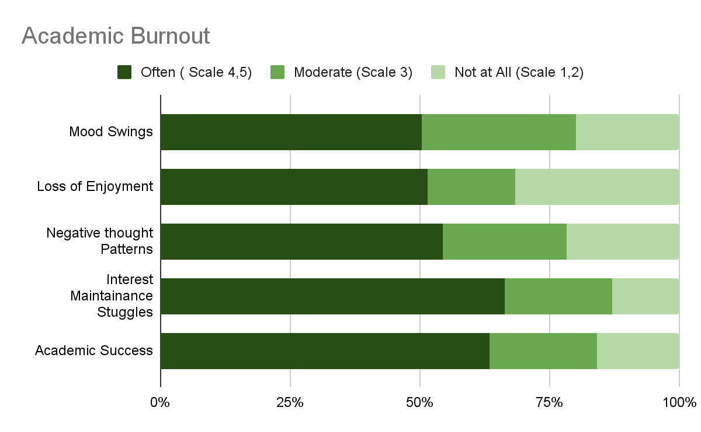
6) Coping Strategies and Effectiveness
- Most common coping mechanisms:
Top Coping Strategies:
  - Recreational activities (video games, music, TV) - 71%
  - Socializing - 51%
  - Time management techniques - 39%
  - Exercise - 26%

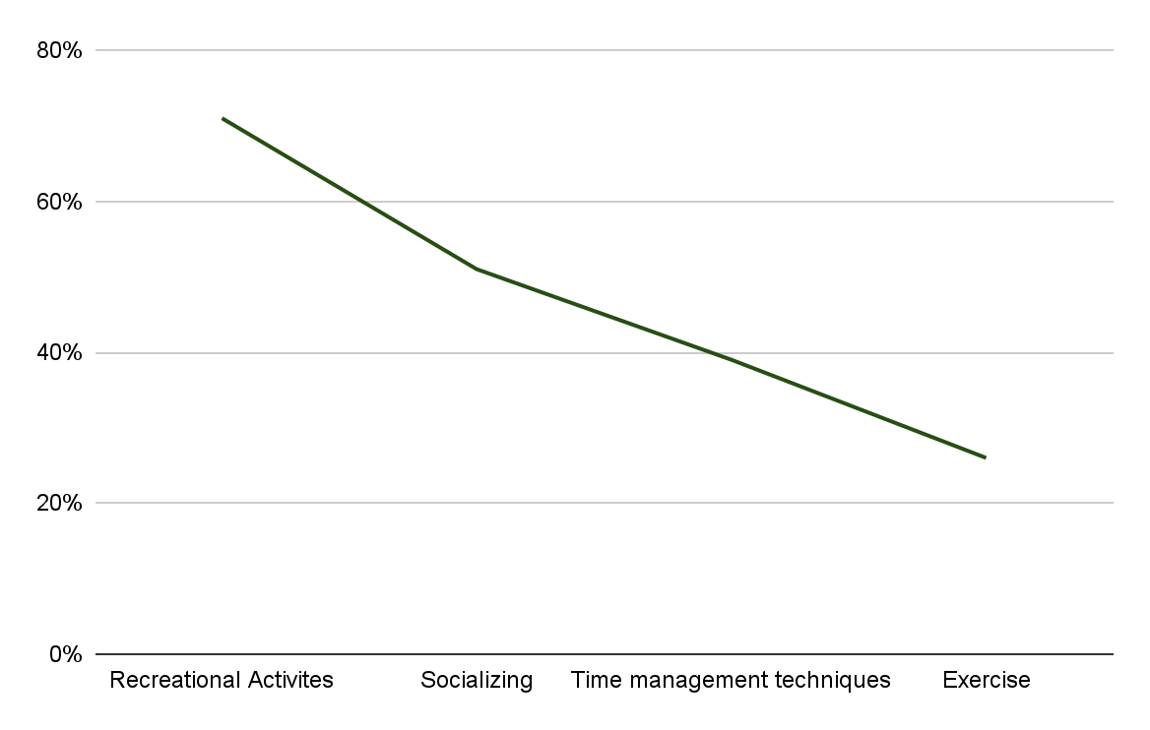
- Perceived effectiveness: Average effectiveness rating of strategies: 3.4/5.
- Professional help seeking: Only 13% have sought professional help (counseling).
- Social support utilization: Approximately 50% rarely reach out for emotional support from friends/family when stressed.
7) Institutional Support Gaps
- Resource availability: 61% say their institution doesn't provide adequate stress management resources.
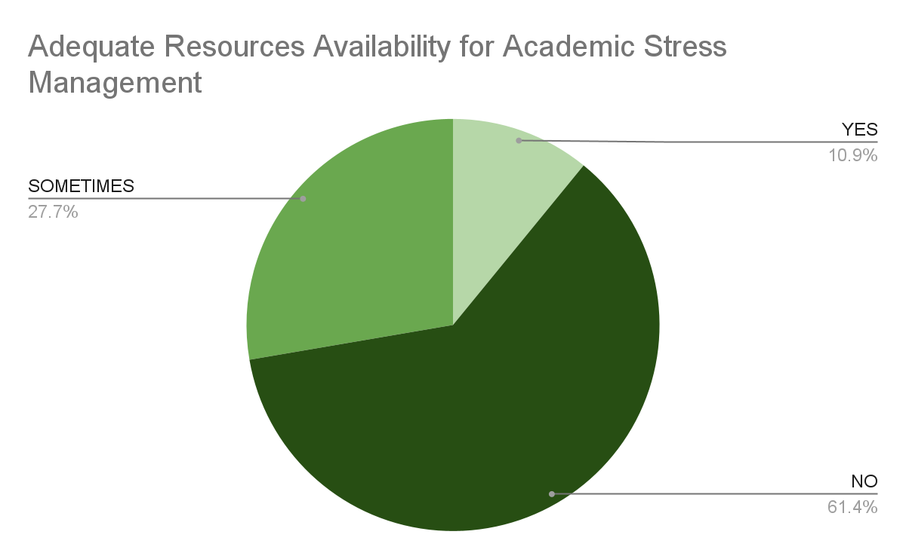
- Service utilization:
Most utilized services:
  - Academic advising (13%)
  - Financial Aid Services (12%)
  - Tutoring centers (12%)
  - Time management or study skills workshops (12%)
Perceived adequacy of support: 62% have used "none of the above" institutional support services
8) Long-term Concerns
Based on Likert Scale (4-5):
- Lasting effects concerns: 48% are concerned about lasting effects on well-being
- Self-confidence impacts: 64% report that academic burnout has affected self-confidence
- Social comparison effects: 59% compare themselves to peers despite feeling exhausted.
9) Gender Based Results:
Female Students:
- Higher Stress Sensitivity: Females reported higher stress levels (average 4.2/5) compared to males (3.8/5) in managing academic responsibilities.
- Anxiety & Sleep: Females experienced more frequent anxiety about deadlines/exams and sleep disturbances due to stress than males.
- Emotional Impact: 68% of females noted that stress negatively affected their happiness/self-esteem.
- Institutional support: 15% of female students use counseling (vs. 10% of males).

Male Students:
- Social Withdrawal: Males reported withdrawing from social activities due to stress more than females.
- Physical Health: Males cited stress-related physical health changes (e.g., fatigue, headaches), slightly higher than females.
- Coping preference: 75% rely on recreational activities (e.g., gaming, TV).

DISCUSSION
What do the Results Mean?
- Chronic Stress is Widespread and Deeply Embedded
The results indicate that chronic academic stress is deeply normalized among students. Even though the majority of respondents are undergraduates aged 16–20, a time theoretically associated with high energy and resilience, they already report high anxiety, burnout, and physical health issues. This suggests that academic environments are overwhelming students at an early stage, setting dangerous patterns that could persist into adulthood.
- Academic Stress is Multidimensional, Affecting Mind and Body
Stress among participants is not limited to academic struggles alone. The data show it spills over into personal relationships, physical health, and self-esteem, highlighting that academic stress is a whole-person issue rather than just a matter of grades or exams. The fact that 79% reported physical health consequences (e.g., headaches, fatigue) and 77% experienced relationship strain reveals how academic demands deeply penetrate students' overall well-being.
- Institutions are Failing to Support Students Effectively
Despite high reported stress levels, institutional support systems are either unavailable, underutilized, or perceived as ineffective. A staggering 62% of students did not use any listed services, suggesting a disconnect between institutional offerings and students’ real needs. This could stem from poor communication about services, perceived stigma, lack of trust, or simply that the services offered are too basic or inaccessible.
- Coping is Predominantly Self-Managed, but Only Moderately Effective
Most students rely on personal coping strategies like recreational activities and socializing rather than formal institutional resources. However, these methods had an average effectiveness rating of just 3.4/5, indicating that while students try to manage stress independently, they cannot fully mitigate the effects of chronic academic pressure.
- Academic Culture Rewards Overwork at the Cost of Well-being
Students report unrealistic expectations, extreme time pressure, and constant peer comparison. This reflects an academic culture that equates constant overwork and sacrifice with success. Given that 66% struggle to maintain interest in tasks they used to enjoy, and 64% report a drop in self-confidence, the cost is not just academic fatigue; it's a gradual erosion of intrinsic motivation and self-worth.
- Burnout is Not Just a Temporary Phase, It Threatens Long-Term Development
The long-term concerns reported (48% fearing lasting effects on well-being) show that students are aware their current stress is not sustainable. Burnout is already impacting academic achievement, mental health, and personal development, creating a cycle that may persist far beyond university life.
Surprising Findings:
- High Stress Did Not Always Correlate with Academic Performance Drops
Even though many students reported high stress levels, not all of them reported a decline in academic performance. Some students maintain grades while quietly suffering severe mental and physical health impacts.
- High Stress Was Not Due to Poor Time Management
Contrary to stereotypes, even students who managed their time well reported severe academic stress. This shows the problem lies more with systemic workload pressure rather than individual failings like procrastination.
- Low Utilization of Support Service
While most students recognized their high stress levels, less than 20% used any available mental health or counseling services.
- Academic Stress Spilled into Personal Life Early
More than 75% of students said academic pressure caused them to lose interest in hobbies and social activities, even before any drop in academic performance.
- Unexpected Engineering Stress Levels
Engineering students (70%) reported higher stress than Business majors, but lower than Medical students. Stress intensity varied significantly even within STEM fields, challenging the idea that all technical disciplines are equally difficult.
Problems:
Sampling Bias: The participants were mainly Computer Science students aged 16–20. Thus, the findings may not generalize to other fields or age groups.
Self-Reporting Bias: Responses were based on self-reporting, which may lead to overestimation or underestimation of stress levels.
Small Sample Size: The number of respondents was relatively limited, which restricts statistical power.
Ambiguity in Some Responses: For example, when asked about institutional support, choosing “maybe” made it hard to tell whether the resources were insufficient or unknown to students.
Repeated Options: Some answer options (like "Exams and test preparation" in stress sources) might have been selected too generally; more diversified options could help pinpoint specific stressors better.

SIGNIFICANCE OF RESEARCH

The findings from this survey on chronic academic stress and its impact on quality of life reveal critical insights into student well-being, institutional support gaps, and the effectiveness of coping strategies. These results are significant for students, educators, policymakers, and mental health professionals for the following reasons:

- Validates the Severity of Academic Stress in Modern Education:
The high prevalence of students frequently experiencing overwhelming academic pressure and stress negatively affects academic performance, physical health, and personal relationships, confirming that academic stress is a systemic issue, not just individual weakness. It highlights the need for structural reforms in education systems to reduce unnecessary pressure.

- Identifies Primary Stressors Requiring Immediate Attention:
It identifies major stressors such as exams, heavy workload, etc, and fields such as computer science, students facing higher workload stress will help institutions redesign curricula (e.g., fewer high-stakes exams, balanced workloads). It will help suggest better communication of course expectations to reduce ambiguity-induced stress.

- Reveals Critical Gender Differences in Stress Response:
Female students are experiencing higher emotional distress and sleep issues, while
Male students show more social withdrawal and physical symptoms, demonstrating the need for gender-specific support approaches. These insights will help develop targeted programs such as stress-management workshops for females and social engagement initiatives for males, while guiding mental health campaigns to address gender-specific coping needs.

- Exposes Gaps in Coping Strategies and Institutional Support:
The revelation that only 13% of students seek professional help despite high stress levels, coupled with 61% reporting inadequate institutional support, underscores critical gaps in current systems. These findings emphasize the urgent need to expand counseling services and implement evidence-based stress management programs while improving awareness of effective coping mechanisms.

- Warns of Long-Term Risks to Student Well-Being:
With 48% of students fearing permanent damage to their well-being and 64% reporting eroded self-confidence due to academic stress, these results sound a clear alarm about the potential for lasting psychological impacts. The findings highlight the necessity for early intervention programs to prevent chronic anxiety, diminished career satisfaction, and lifelong self-esteem issues stemming from academic pressure.

CONCLUSION
This survey revealed that academic stress is a widespread and deeply systemic issue, impacting not only students’ academic performance but also their mental and physical well-being. It showed that many students face chronic stress due to unrealistic academic expectations, heavy workloads, and limited institutional support. While coping strategies like recreation and socializing provide temporary relief, they are often insufficient. The study also highlighted gender-based differences in stress responses and exposed alarming long-term consequences such as burnout, loss of motivation, and deteriorating mental health.
Future research should explore the effectiveness of specific institutional interventions, such as curriculum reforms and mental health support programs, in reducing academic stress. Studies could also examine stress responses across a wider range of demographics, including socioeconomic backgrounds and academic disciplines, to develop more targeted support systems. Additionally, longitudinal studies tracking the long-term psychological and career-related impacts of academic burnout would offer deeper insights into the lasting effects of chronic stress on students’ lives.

